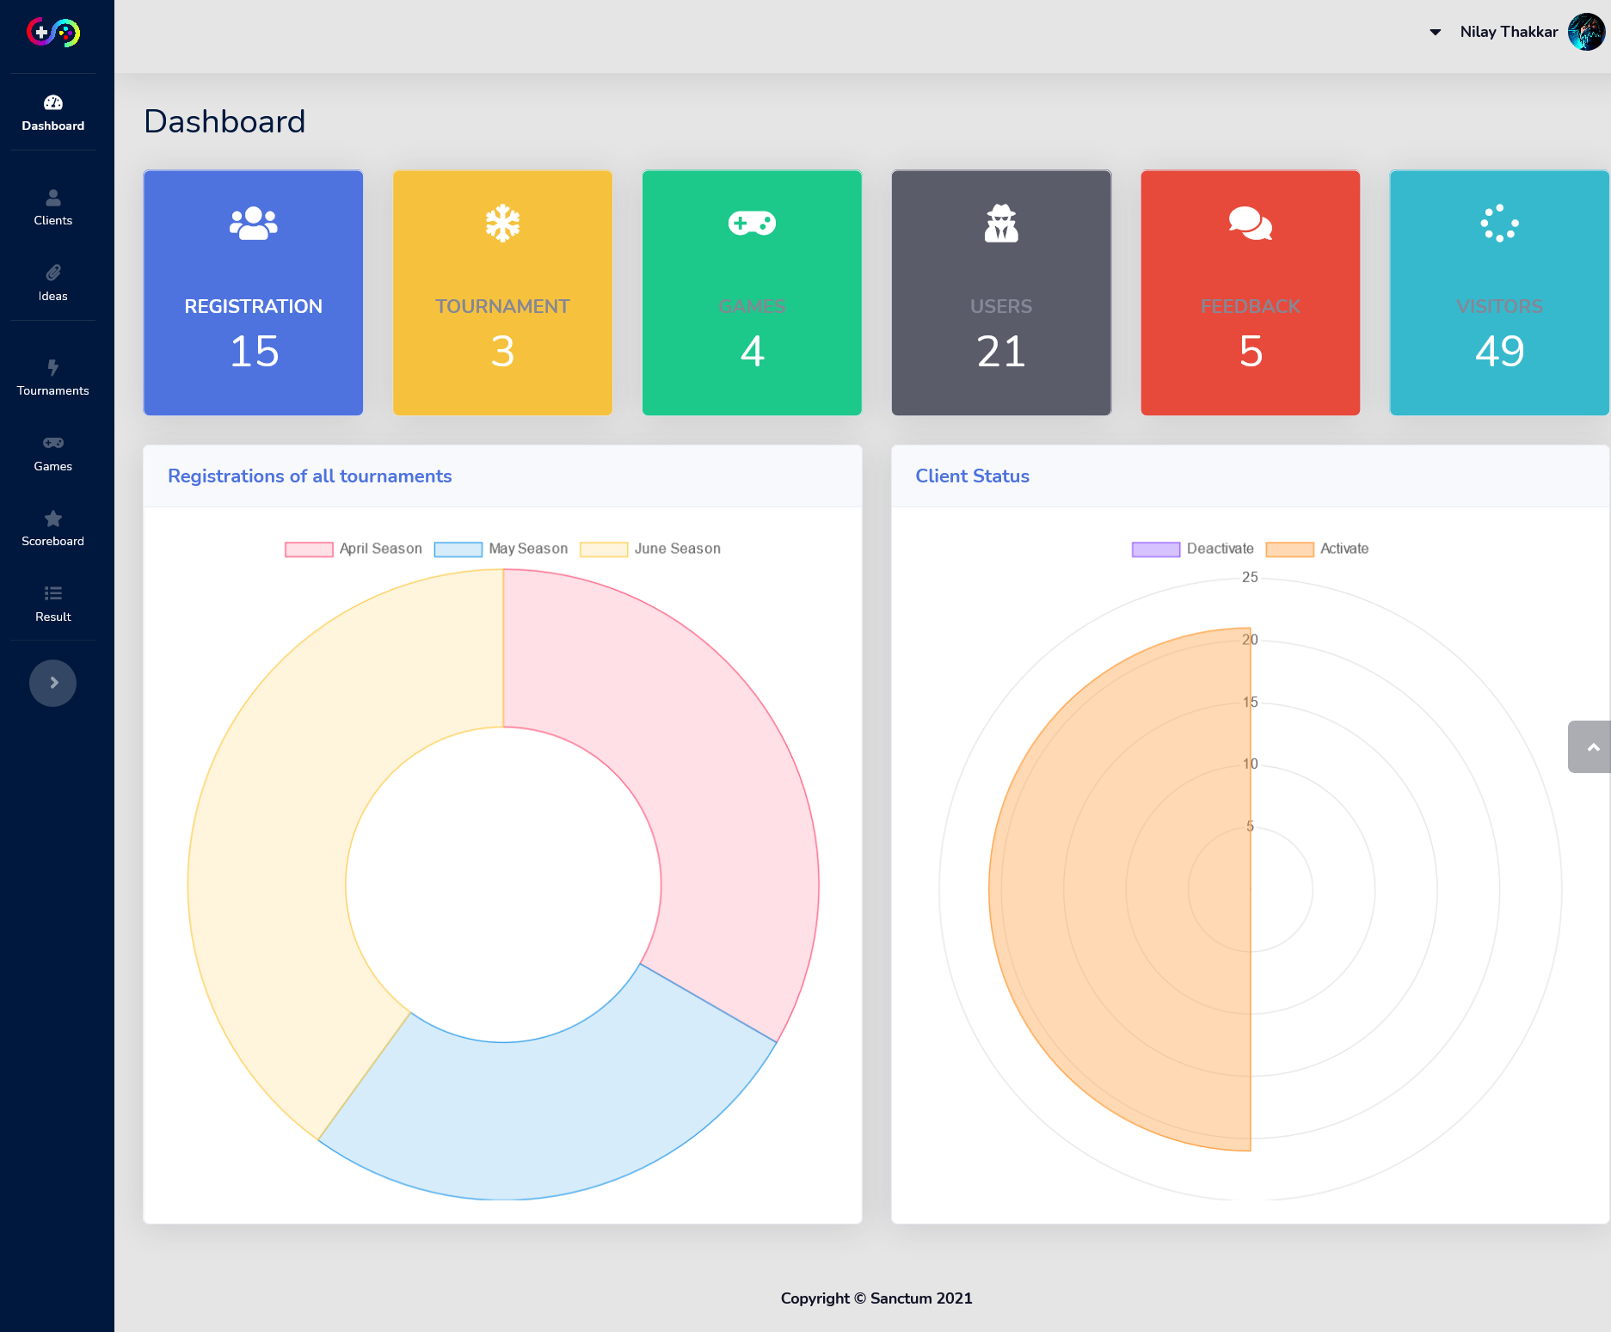

Dashboard-Here you can see all details related to tournament

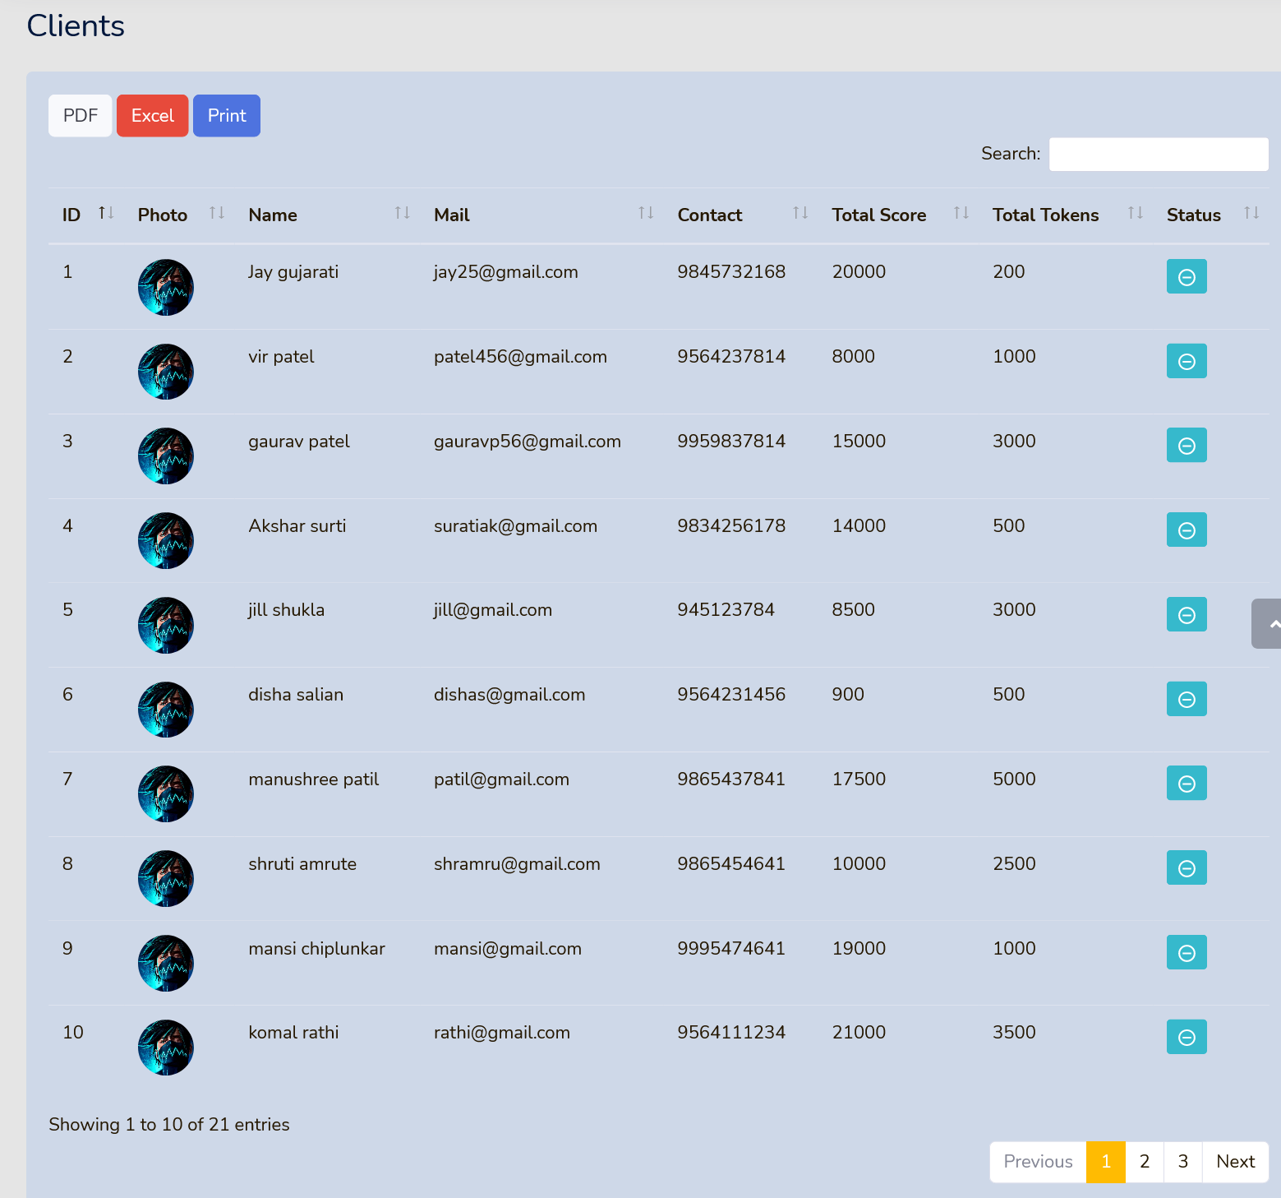

Client Table-Here you can see details of all clients

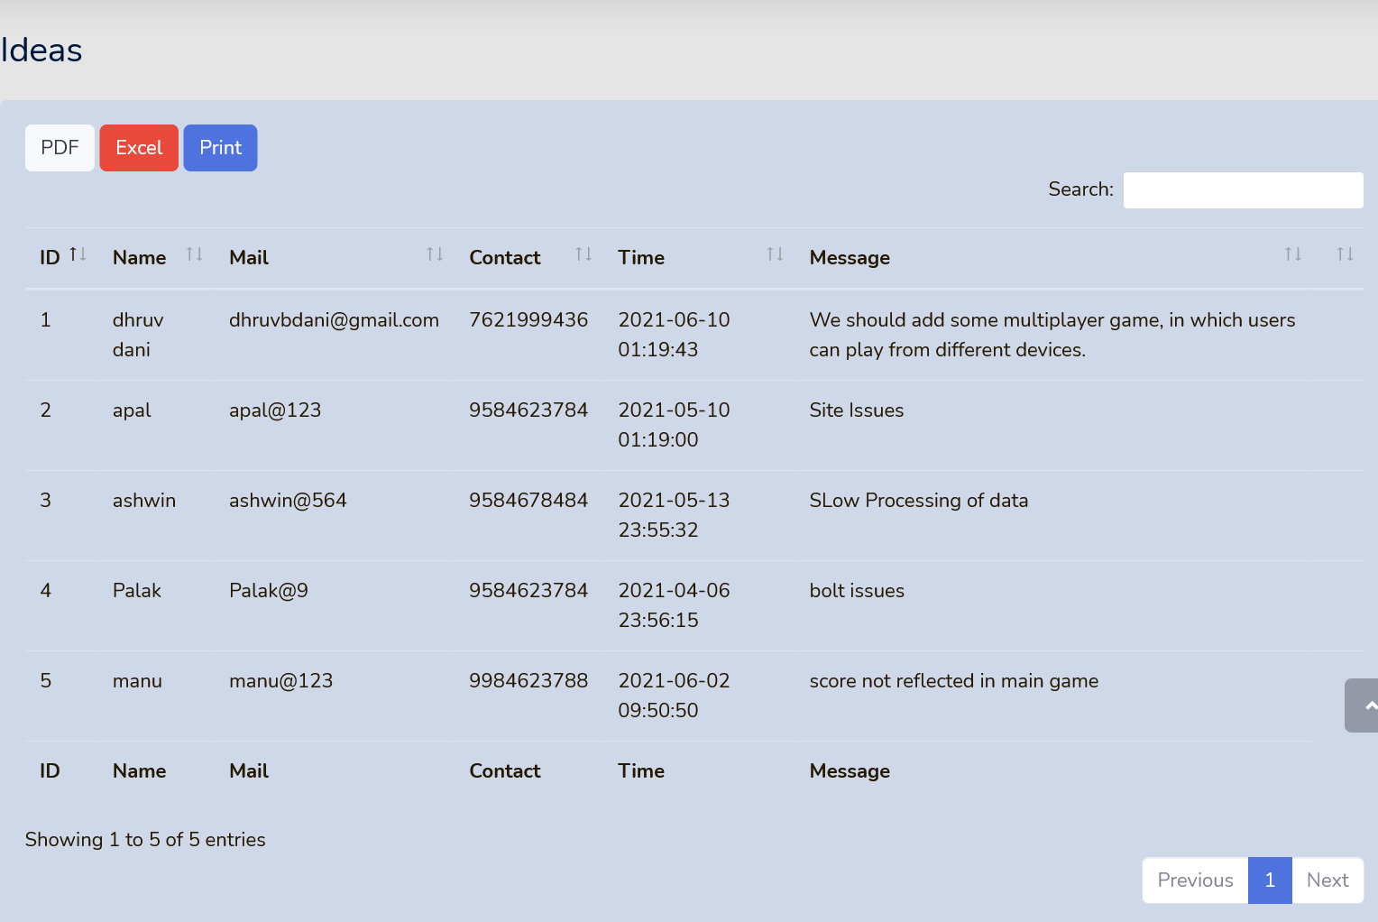

Ideas Table - Here you can see all feedbacks given by client

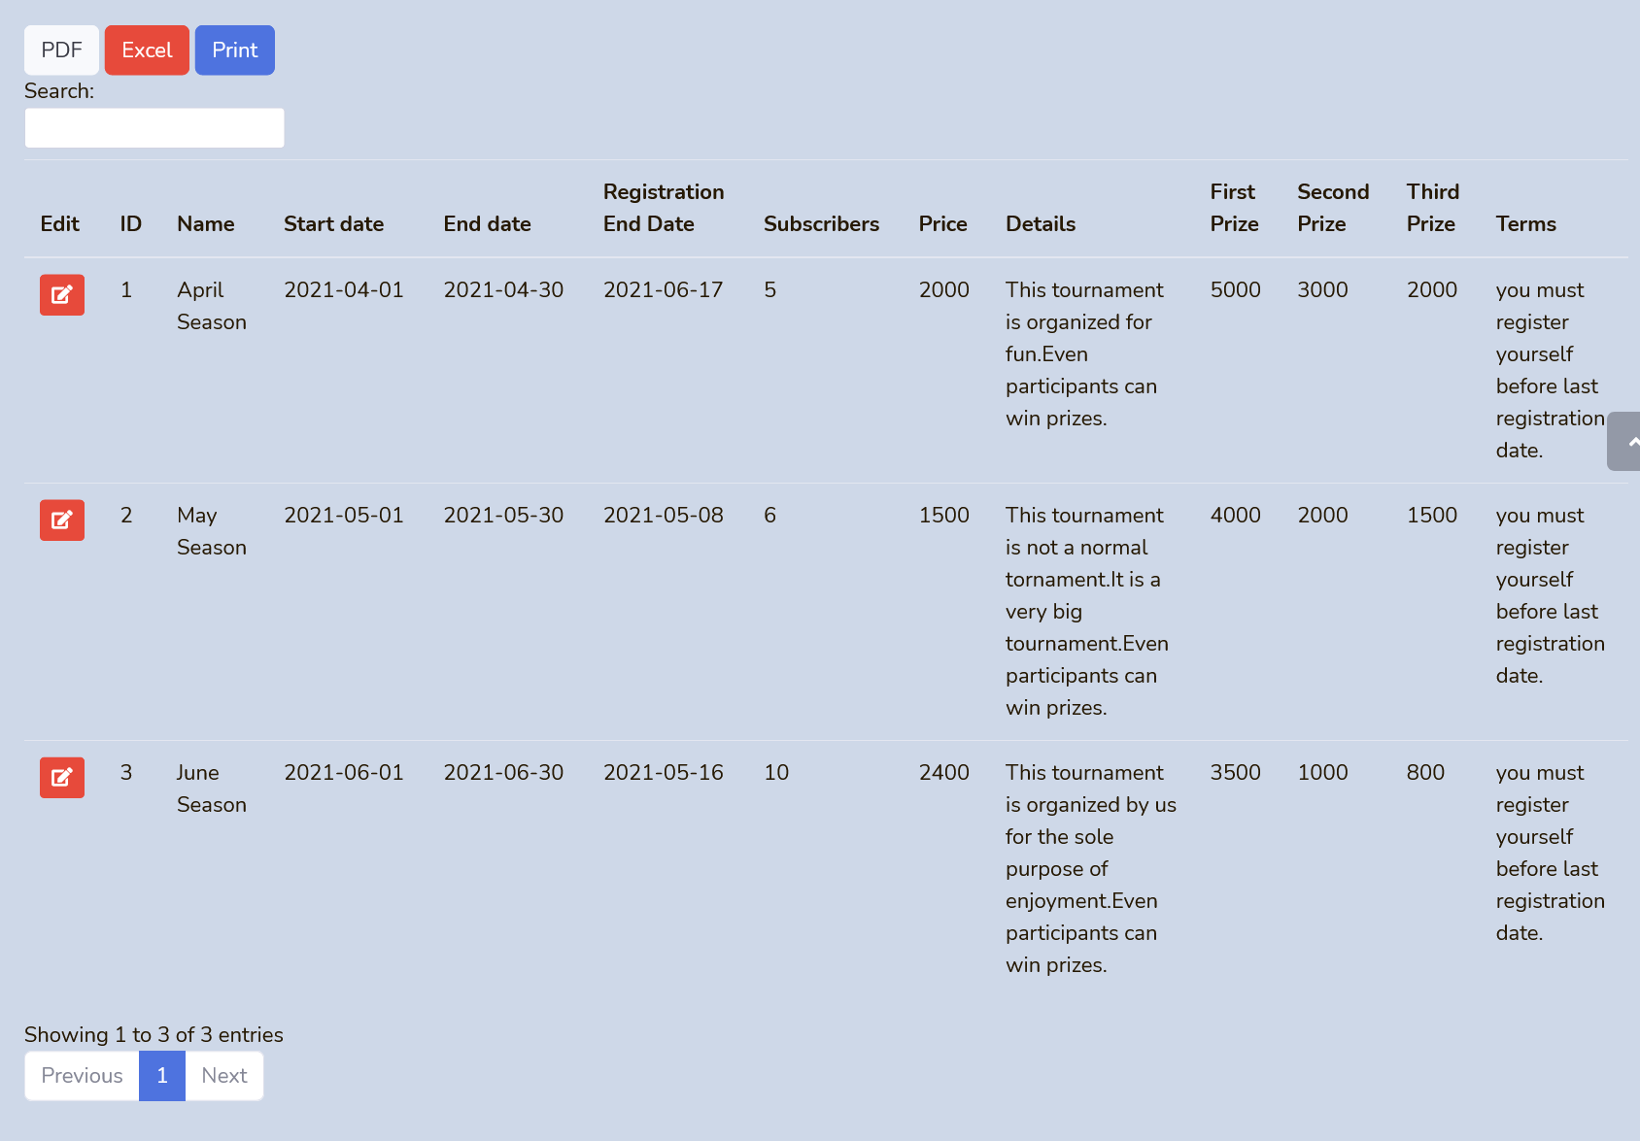

Tournament Table - You can see details of all tournaments here

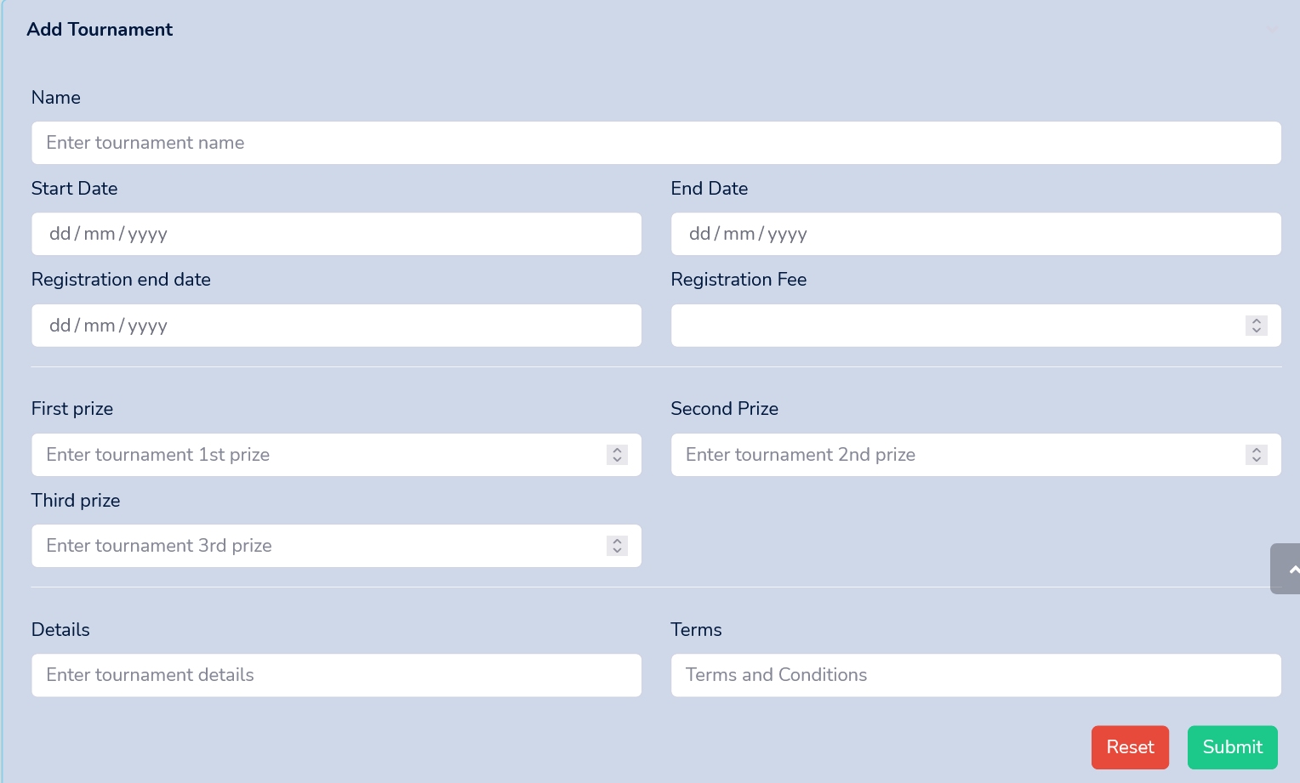

Add Tournament - You can add a tournament from here

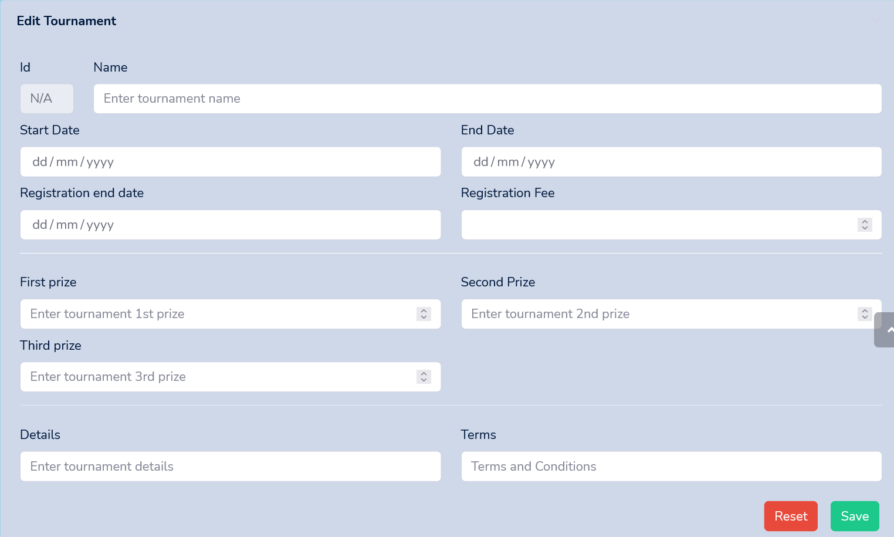

Edit Tournament – You can edit tournament details form here

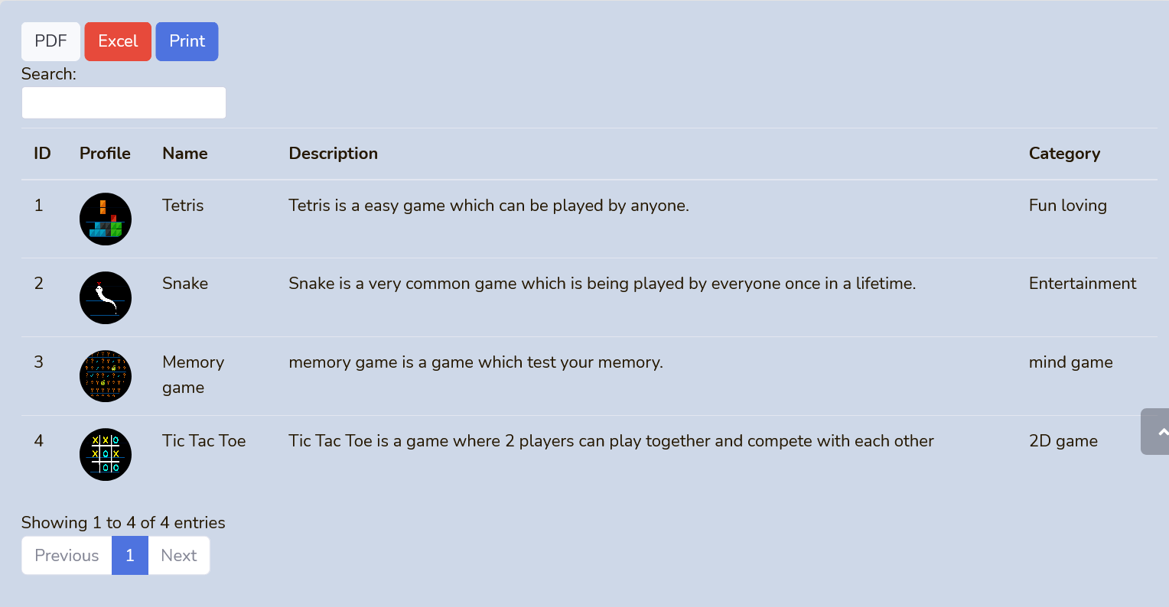

Games Tables - Here you can see description of all the games present on sanctum platform

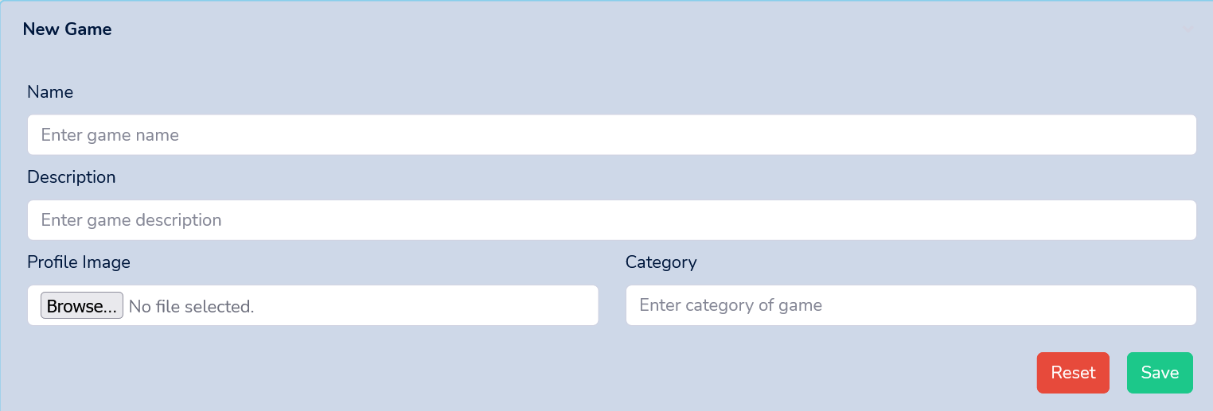

New Game-Here you can issue details of new game

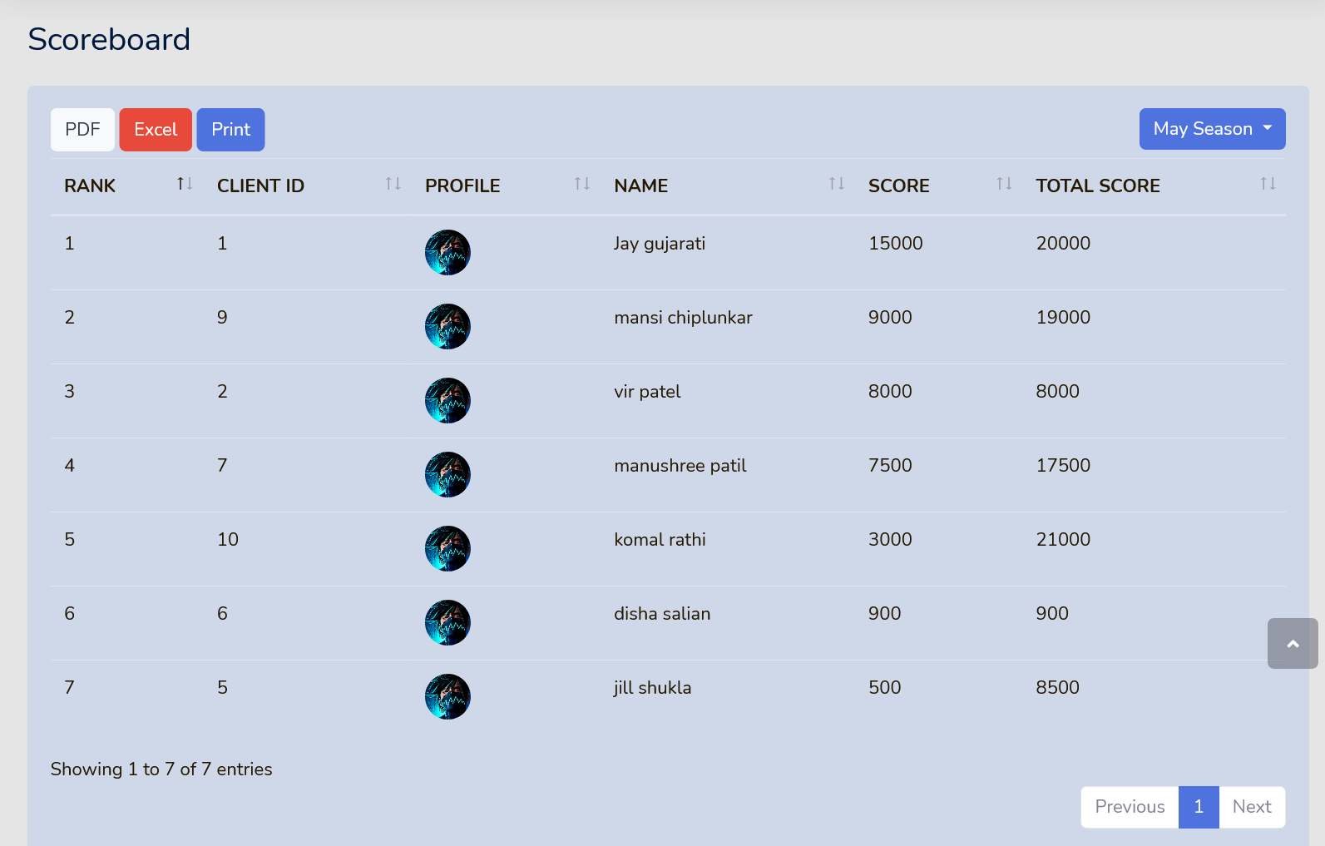

Scoreboard Table - Here you can see scores of all clients who have participated in a particular tournament

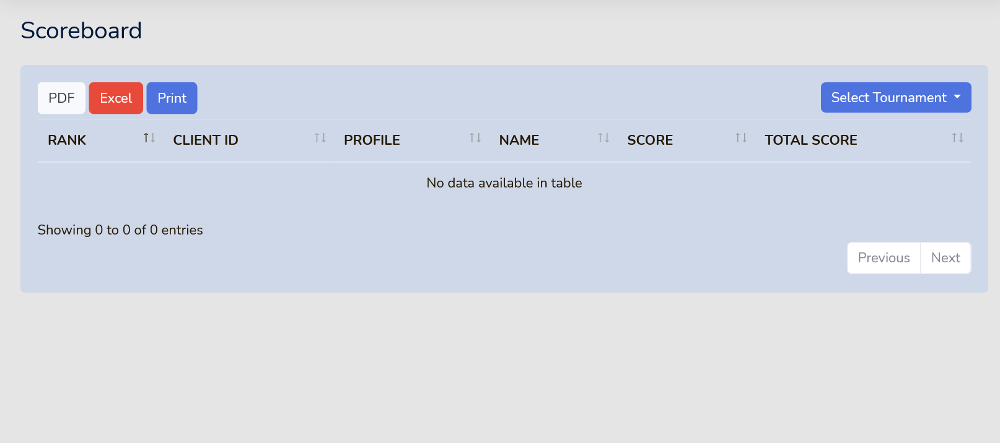

Scoreboard section – Here you need to select tournament to view scores

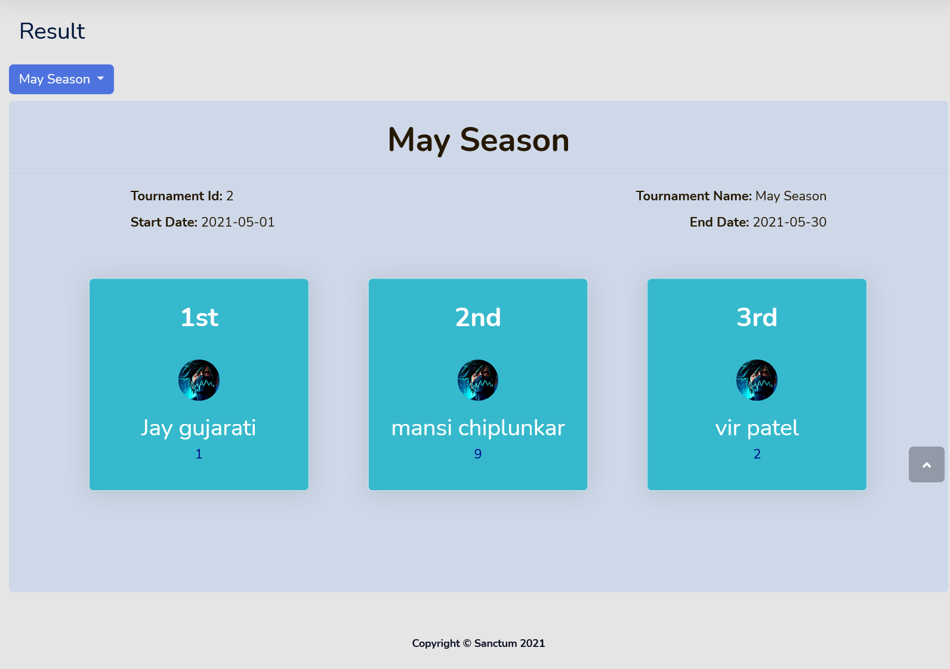

Result Table – Here u can see results of a particular tournament

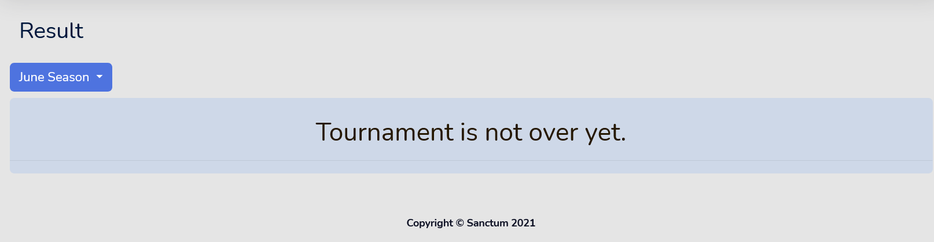

Result section – result of current tournament cannot be displayed so appropriate message is shown

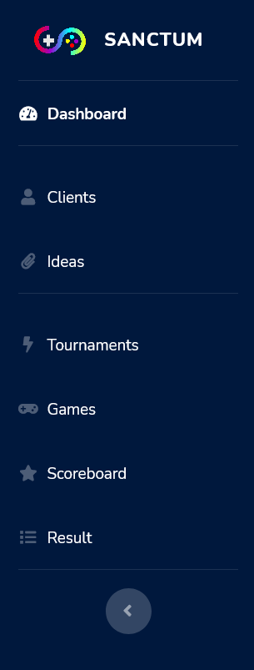

Navigation bar - Form Here you can navigate to different pages

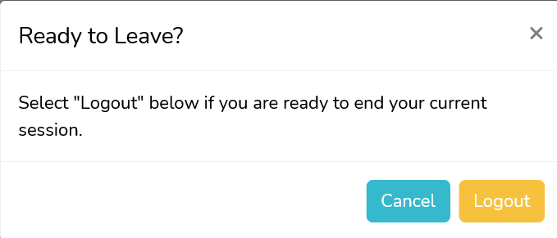

Logout – From here admin user can logout

**FULL PAGE SS**

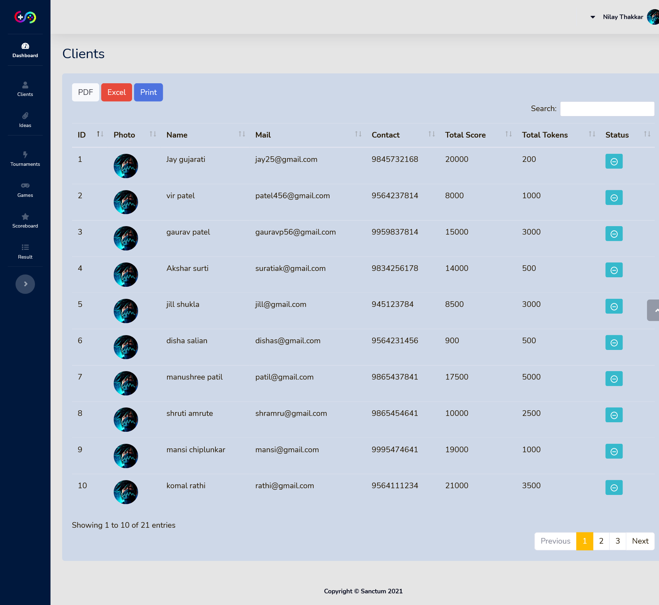

Client Section - Here you can see details of all clients

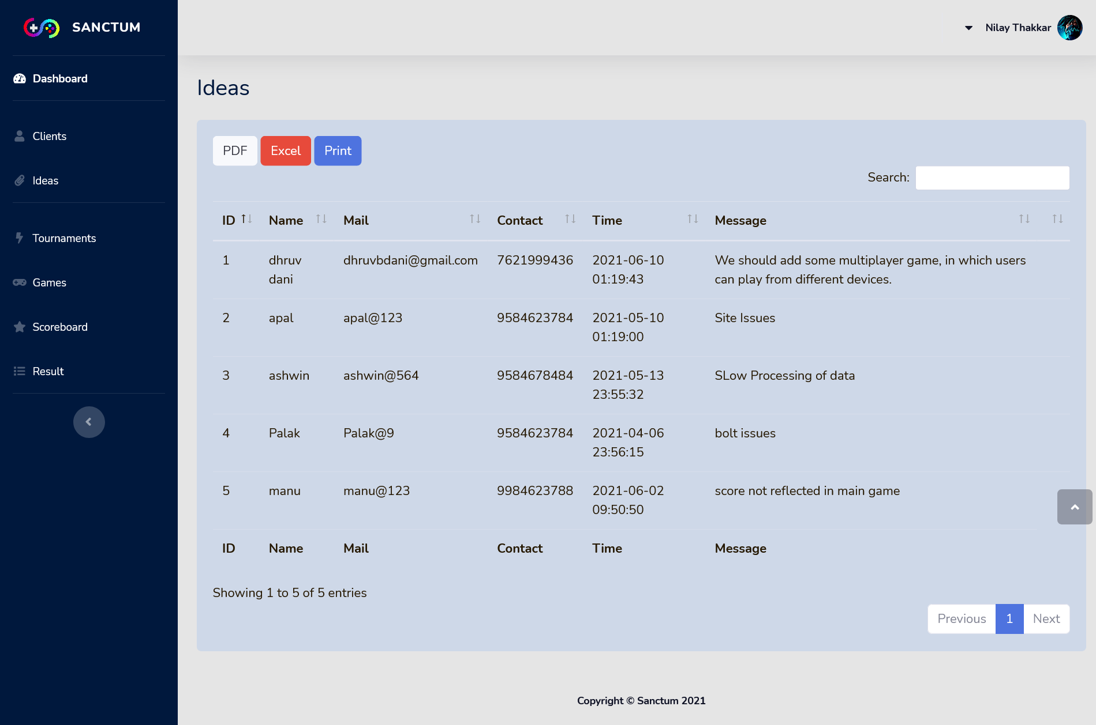

Ideas Section - Here you can see all feedbacks given by client

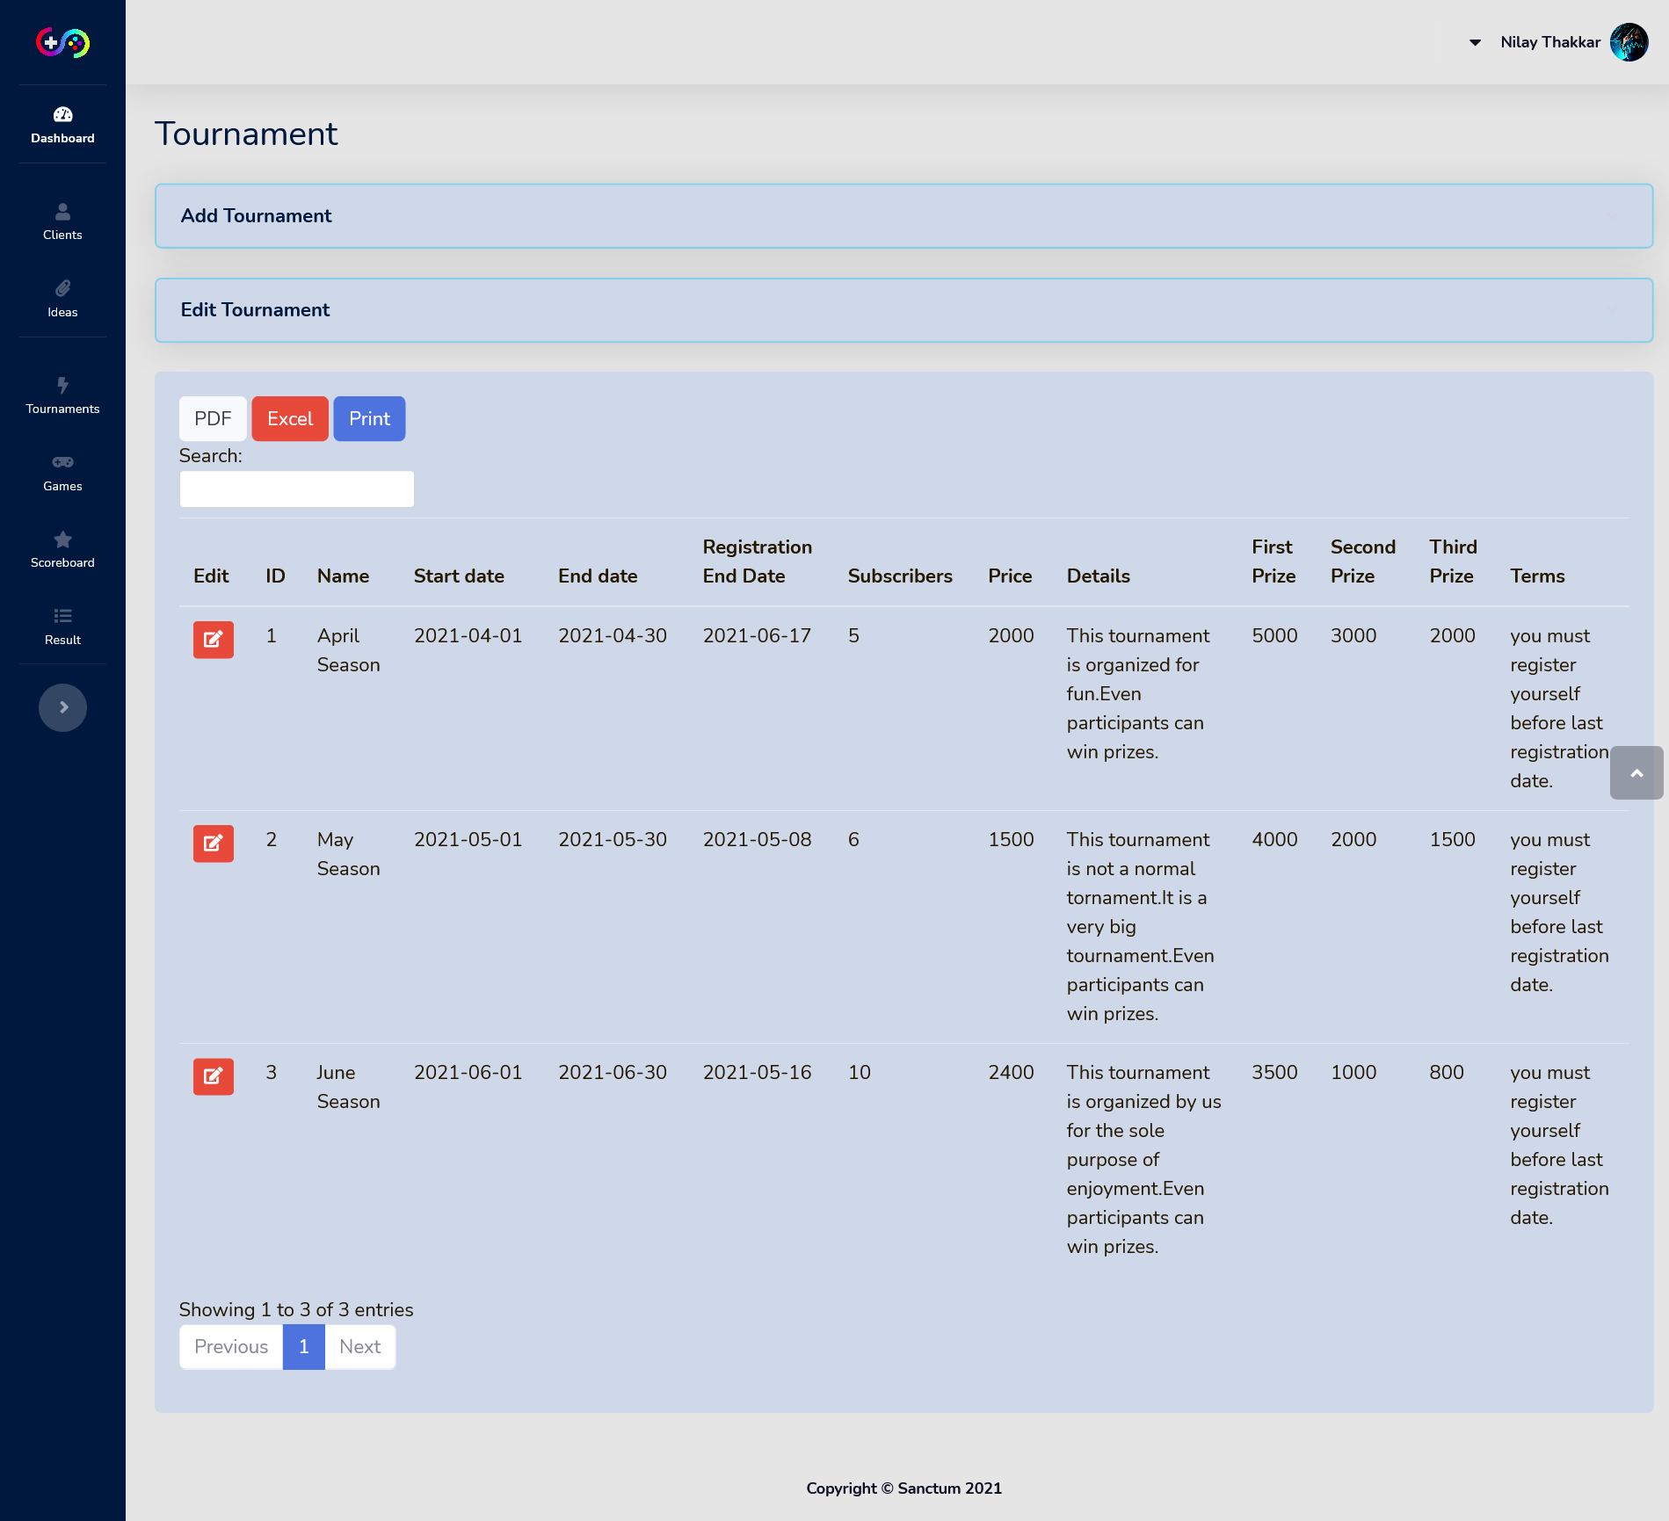

Tournament Section - You can see details of all tournaments here

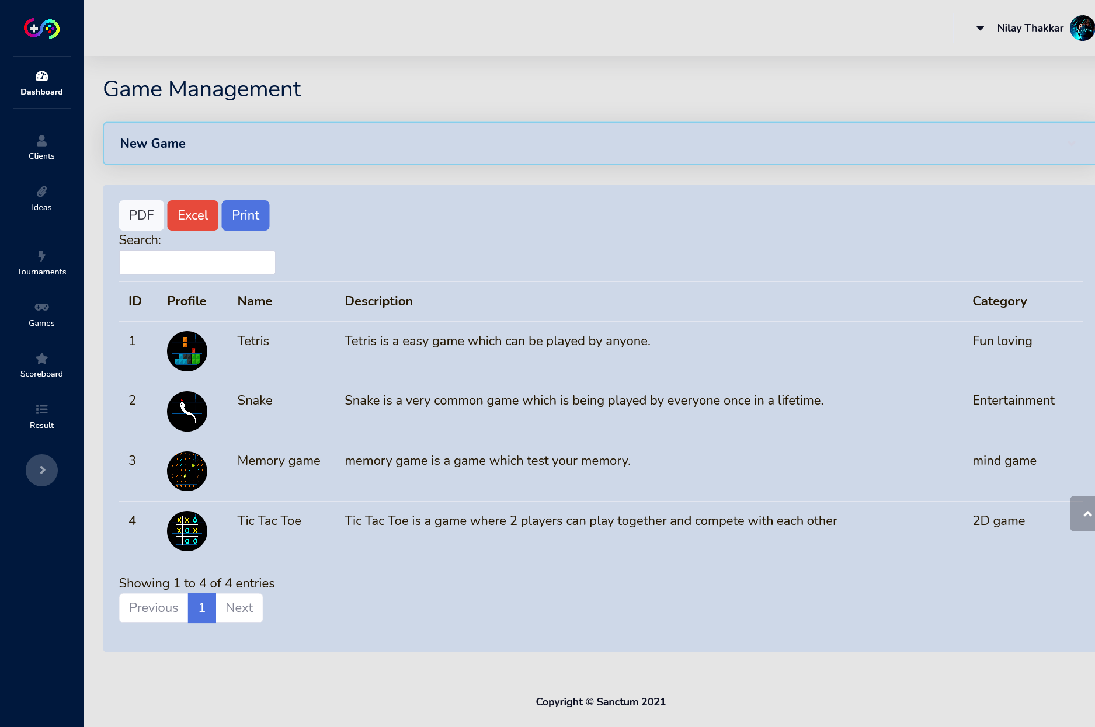

Games Section - Here you can see description of all the games present on sanctum platform

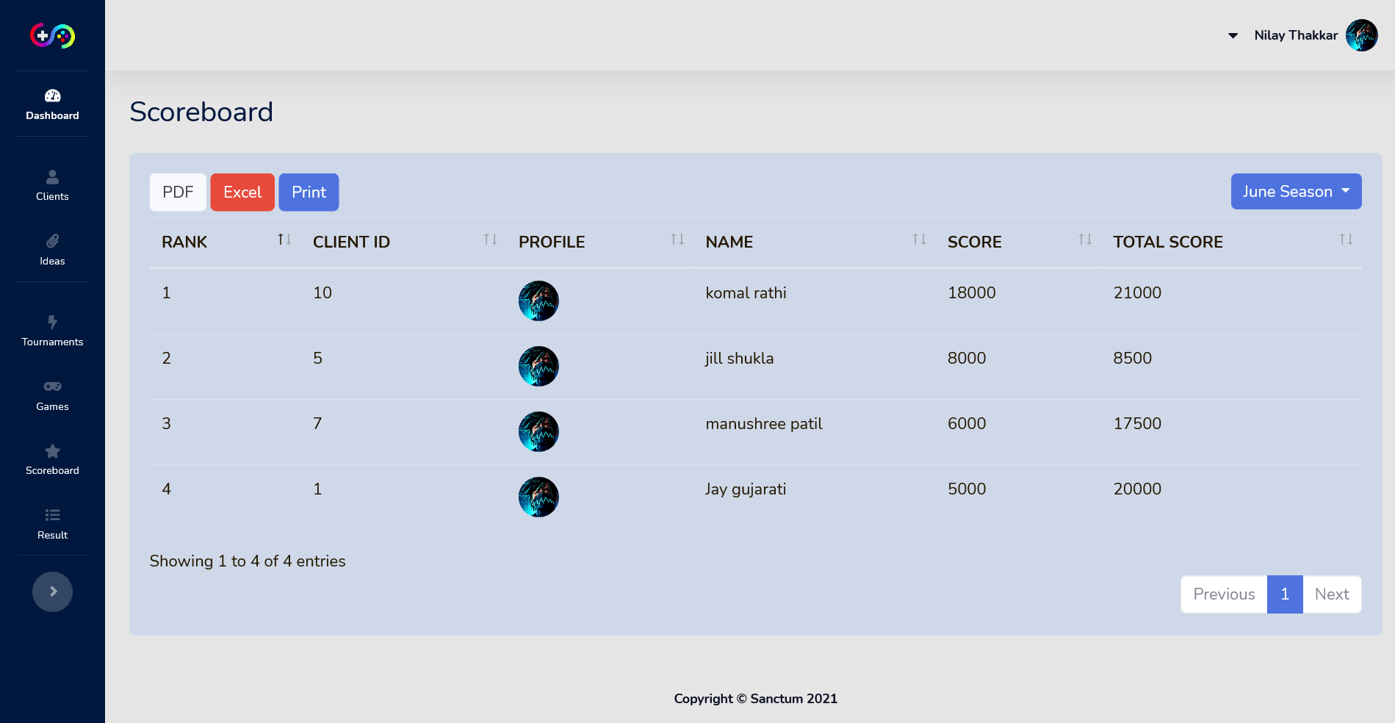

Scoreboard Section - Here you can see scores of all clients who have participated in a particular tournament

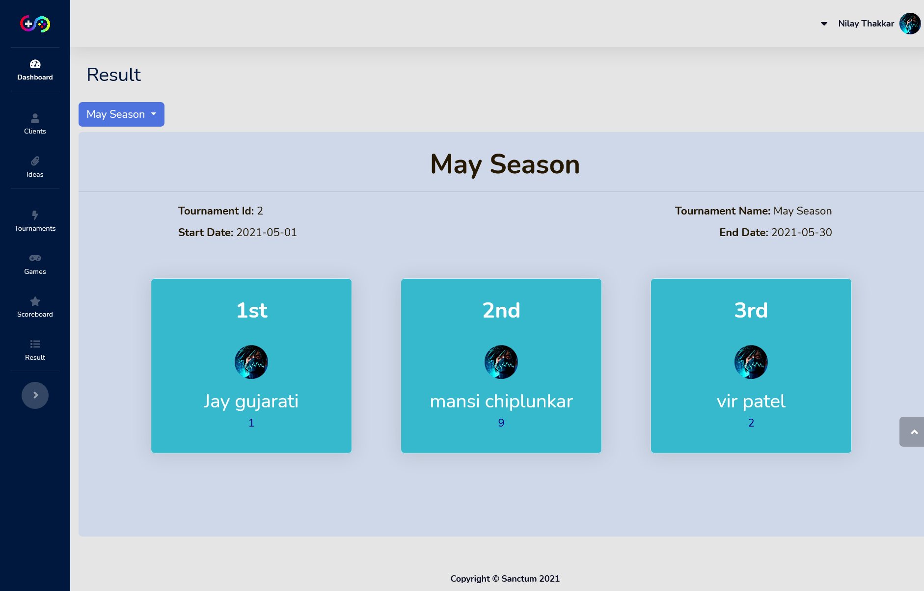

Result Section - result of current tournament cannot be displayed so appropriate message is shown

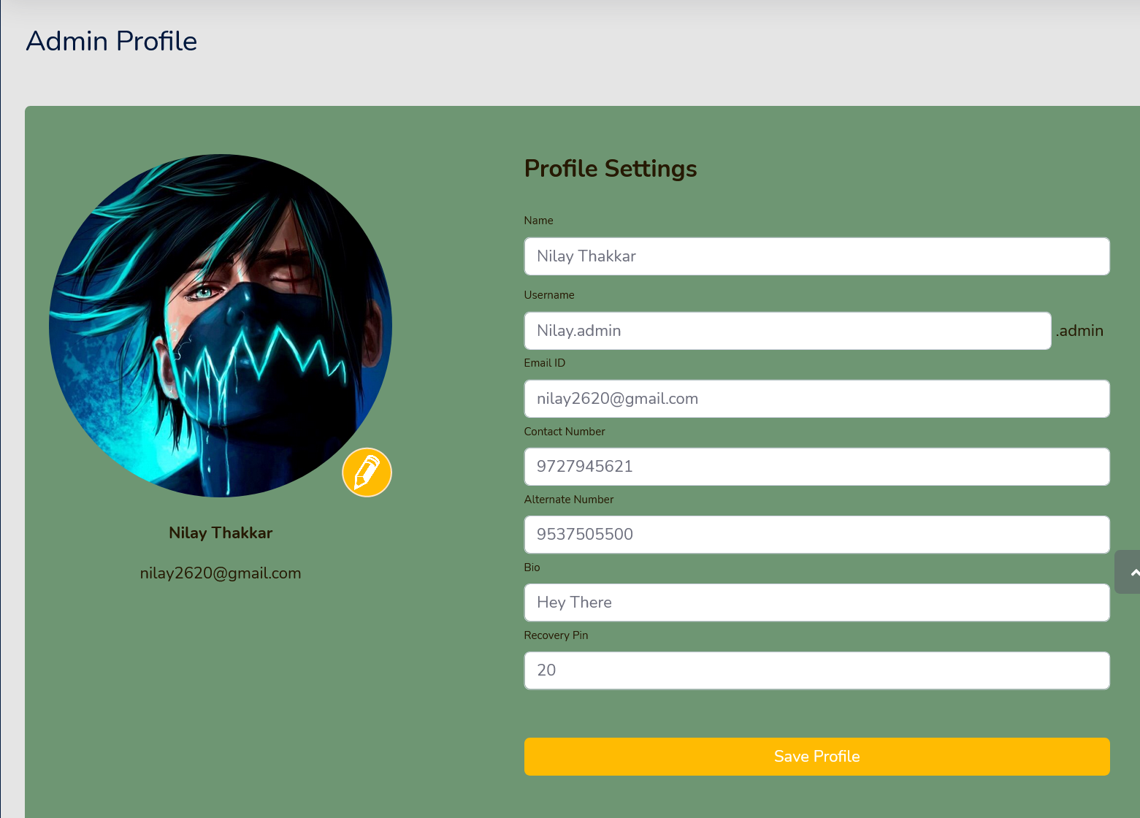

Admin profile – Here admin can change his profile details